Supplementary Material
Shortcuts and Temporal Leakage in the Bangalore EEG Epilepsy Dataset: a Provenance Audit and Leakage-Aware Benchmark of Lightweight Seizure-Type Classifiers
This document contains extended tables, additional figures, hyper-parameter grids and full per-fold results. Supplementary File S1 is the accompanying code-and-results archive (run_all.py, src/, results/, figures/, analysis.ipynb). All values were generated by that code.

S1 Hyper-parameter grids and selected values
Table S1. Hyper-parameter search grids (inner three-fold CV, macro-F1)
Model | Grid | Fixed settings
Majority | – | –
LR | C ∈ [0.01, 0.1, 1, 10, 100] | –
kNN | n_neighbors ∈ [1, 5, 15, 31]; weights ∈ ['uniform', 'distance'] | –
SVM-RBF | C ∈ [1, 10, 100]; gamma ∈ ['scale', 0.01] | –
RF | max_features ∈ ['sqrt', 0.3]; min_samples_leaf ∈ [1, 5] | n_estimators=300
XGBoost | max_depth ∈ [3, 6]; learning_rate ∈ [0.05, 0.2] | colsample_bytree=0.8; n_estimators=300; subsample=0.8
LightGBM | num_leaves ∈ [15, 63]; learning_rate ∈ [0.05, 0.2] | colsample_bytree=0.8; n_estimators=300; subsample=0.8
MLP | – (fixed architecture) | AdamW lr 0.002, weight decay 1e-4, batch 128, ≤60 epochs, patience 8
1D-CNN | – (fixed architecture) | AdamW lr 0.002, weight decay 1e-4, batch 128, ≤60 epochs, patience 8
BiLSTM | – (fixed architecture) | AdamW lr 0.002, weight decay 1e-4, batch 128, ≤60 epochs, patience 8
Transformer | – (fixed architecture) | AdamW lr 0.002, weight decay 1e-4, batch 128, ≤60 epochs, patience 8

Table S2. Hyper-parameters selected on the development set for each hold-out run
Task | Protocol | Features | Model | Selected
4class | random | raw | LR | {logisticregression__C: 0.01}
4class | random | raw | kNN | {kneighborsclassifier__n_neighbors: 1, kneighborsclassifier__weights: uniform}
4class | random | raw | SVM-RBF | {svc__C: 100, svc__gamma: scale}
4class | random | raw | RF | {max_features: sqrt, min_samples_leaf: 1}
4class | random | raw | XGBoost | {learning_rate: 0.2, max_depth: 6}
4class | random | raw | LightGBM | {learning_rate: 0.2, num_leaves: 63}
4class | random | eng | LR | {logisticregression__C: 10}
4class | random | eng | kNN | {kneighborsclassifier__n_neighbors: 1, kneighborsclassifier__weights: uniform}
4class | random | eng | SVM-RBF | {svc__C: 100, svc__gamma: scale}
4class | random | eng | RF | {max_features: 0.3, min_samples_leaf: 1}
4class | random | eng | XGBoost | {learning_rate: 0.2, max_depth: 6}
4class | random | eng | LightGBM | {learning_rate: 0.05, num_leaves: 63}
4class | random | raw+eng | LR | {logisticregression__C: 100}
4class | random | raw+eng | kNN | {kneighborsclassifier__n_neighbors: 1, kneighborsclassifier__weights: uniform}
4class | random | raw+eng | SVM-RBF | {svc__C: 100, svc__gamma: scale}
4class | random | raw+eng | RF | {max_features: 0.3, min_samples_leaf: 1}
4class | random | raw+eng | XGBoost | {learning_rate: 0.2, max_depth: 6}
4class | random | raw+eng | LightGBM | {learning_rate: 0.05, num_leaves: 63}
4class | blocked | raw | LR | {logisticregression__C: 100}
4class | blocked | raw | kNN | {kneighborsclassifier__n_neighbors: 5, kneighborsclassifier__weights: uniform}
4class | blocked | raw | SVM-RBF | {svc__C: 100, svc__gamma: scale}
4class | blocked | raw | RF | {max_features: sqrt, min_samples_leaf: 1}
4class | blocked | raw | XGBoost | {learning_rate: 0.2, max_depth: 3}
4class | blocked | raw | LightGBM | {learning_rate: 0.05, num_leaves: 15}
4class | blocked | eng | LR | {logisticregression__C: 100}
4class | blocked | eng | kNN | {kneighborsclassifier__n_neighbors: 15, kneighborsclassifier__weights: distance}
4class | blocked | eng | SVM-RBF | {svc__C: 100, svc__gamma: 0.01}
4class | blocked | eng | RF | {max_features: sqrt, min_samples_leaf: 1}
4class | blocked | eng | XGBoost | {learning_rate: 0.2, max_depth: 3}
4class | blocked | eng | LightGBM | {learning_rate: 0.2, num_leaves: 15}
4class | blocked | raw+eng | LR | {logisticregression__C: 100}
4class | blocked | raw+eng | kNN | {kneighborsclassifier__n_neighbors: 15, kneighborsclassifier__weights: distance}
4class | blocked | raw+eng | SVM-RBF | {svc__C: 10, svc__gamma: scale}
4class | blocked | raw+eng | RF | {max_features: 0.3, min_samples_leaf: 1}
4class | blocked | raw+eng | XGBoost | {learning_rate: 0.2, max_depth: 3}
4class | blocked | raw+eng | LightGBM | {learning_rate: 0.2, num_leaves: 15}
binary | random | raw+eng | LR | {logisticregression__C: 1}
binary | random | raw+eng | kNN | {kneighborsclassifier__n_neighbors: 1, kneighborsclassifier__weights: uniform}
binary | random | raw+eng | SVM-RBF | {svc__C: 1, svc__gamma: scale}
binary | random | raw+eng | RF | {max_features: sqrt, min_samples_leaf: 1}
binary | random | raw+eng | XGBoost | {learning_rate: 0.05, max_depth: 3}
binary | random | raw+eng | LightGBM | {learning_rate: 0.05, num_leaves: 15}
binary | blocked | raw+eng | LR | {logisticregression__C: 10}
binary | blocked | raw+eng | kNN | {kneighborsclassifier__n_neighbors: 5, kneighborsclassifier__weights: uniform}
binary | blocked | raw+eng | SVM-RBF | {svc__C: 10, svc__gamma: 0.01}
binary | blocked | raw+eng | RF | {max_features: sqrt, min_samples_leaf: 1}
binary | blocked | raw+eng | XGBoost | {learning_rate: 0.05, max_depth: 3}
binary | blocked | raw+eng | LightGBM | {learning_rate: 0.05, num_leaves: 15}
3class | random | raw+eng | LR | {logisticregression__C: 100}
3class | random | raw+eng | kNN | {kneighborsclassifier__n_neighbors: 1, kneighborsclassifier__weights: uniform}
3class | random | raw+eng | SVM-RBF | {svc__C: 100, svc__gamma: scale}
3class | random | raw+eng | RF | {max_features: 0.3, min_samples_leaf: 1}
3class | random | raw+eng | XGBoost | {learning_rate: 0.2, max_depth: 6}
3class | random | raw+eng | LightGBM | {learning_rate: 0.05, num_leaves: 63}
3class | blocked | raw+eng | LR | {logisticregression__C: 1}
3class | blocked | raw+eng | kNN | {kneighborsclassifier__n_neighbors: 15, kneighborsclassifier__weights: uniform}
3class | blocked | raw+eng | SVM-RBF | {svc__C: 10, svc__gamma: 0.01}
3class | blocked | raw+eng | RF | {max_features: 0.3, min_samples_leaf: 1}
3class | blocked | raw+eng | XGBoost | {learning_rate: 0.2, max_depth: 3}
3class | blocked | raw+eng | LightGBM | {learning_rate: 0.2, num_leaves: 15}

S2 Extended hold-out results
Table S3. Four-class hold-out results for all models and feature sets
Protocol | Features | Model | Accuracy | Macro-F1 | Kappa | AUC | Brier | ECE | Fit (s)
random | eng | LightGBM | 0.916 | 0.916 | 0.888 | 0.988 | 0.128 | 0.025 | 10.9
random | eng | XGBoost | 0.909 | 0.909 | 0.878 | 0.985 | 0.140 | 0.019 | 8.8
random | eng | kNN | 0.902 | 0.903 | 0.870 | 0.935 | 0.195 | 0.098 | 0.4
random | eng | SVM-RBF | 0.889 | 0.890 | 0.853 | 0.979 | 0.165 | 0.034 | 14.5
random | eng | RF | 0.871 | 0.871 | 0.828 | 0.978 | 0.212 | 0.114 | 24.3
random | eng | LR | 0.749 | 0.749 | 0.666 | 0.925 | 0.323 | 0.033 | 4.3
random | eng | Majority | 0.250 | 0.100 | 0.000 | 0.500 | 0.750 | 0.000 | 0.0
random | raw | kNN | 0.986 | 0.986 | 0.982 | 0.991 | 0.028 | 0.014 | 0.2
random | raw | LightGBM | 0.986 | 0.986 | 0.981 | 0.999 | 0.025 | 0.010 | 3.4
random | raw | XGBoost | 0.976 | 0.976 | 0.968 | 0.999 | 0.035 | 0.009 | 2.5
random | raw | RF | 0.964 | 0.964 | 0.953 | 0.998 | 0.096 | 0.133 | 7.5
random | raw | 1D-CNN | 0.956 | 0.956 | 0.941 | 0.997 | 0.066 | 0.015 | 9.0
random | raw | MLP | 0.932 | 0.933 | 0.910 | 0.994 | 0.091 | 0.029 | 7.1
random | raw | Transformer | 0.921 | 0.921 | 0.895 | 0.988 | 0.121 | 0.018 | 32.5
random | raw | SVM-RBF | 0.903 | 0.903 | 0.871 | 0.983 | 0.145 | 0.027 | 6.7
random | raw | BiLSTM | 0.706 | 0.697 | 0.607 | 0.893 | 0.374 | 0.029 | 9.0
random | raw | LR | 0.477 | 0.483 | 0.302 | 0.657 | 0.680 | 0.127 | 2.8
random | raw | Majority | 0.250 | 0.100 | 0.000 | 0.500 | 0.750 | 0.000 | 0.0
random | raw+eng | LightGBM | 0.973 | 0.973 | 0.964 | 0.999 | 0.039 | 0.010 | 14.8
random | raw+eng | XGBoost | 0.962 | 0.962 | 0.949 | 0.997 | 0.053 | 0.009 | 9.1
random | raw+eng | RF | 0.943 | 0.943 | 0.924 | 0.994 | 0.135 | 0.136 | 28.3
random | raw+eng | SVM-RBF | 0.928 | 0.928 | 0.904 | 0.990 | 0.111 | 0.036 | 13.6
random | raw+eng | kNN | 0.926 | 0.926 | 0.902 | 0.951 | 0.147 | 0.074 | 0.4
random | raw+eng | LR | 0.761 | 0.760 | 0.681 | 0.931 | 0.311 | 0.030 | 15.8
random | raw+eng | Majority | 0.250 | 0.100 | 0.000 | 0.500 | 0.750 | 0.000 | 0.0
blocked | eng | LR | 0.707 | 0.705 | 0.609 | 0.909 | 0.357 | 0.054 | 5.8
blocked | eng | SVM-RBF | 0.702 | 0.697 | 0.603 | 0.891 | 0.426 | 0.124 | 10.7
blocked | eng | LightGBM | 0.699 | 0.690 | 0.599 | 0.889 | 0.497 | 0.208 | 7.0
blocked | eng | XGBoost | 0.695 | 0.686 | 0.593 | 0.894 | 0.419 | 0.129 | 5.9
blocked | eng | RF | 0.686 | 0.664 | 0.581 | 0.882 | 0.393 | 0.029 | 15.6
blocked | eng | kNN | 0.649 | 0.631 | 0.532 | 0.847 | 0.462 | 0.094 | 0.3
blocked | eng | Majority | 0.250 | 0.100 | 0.000 | 0.500 | 0.750 | 0.007 | 0.0
blocked | raw | SVM-RBF | 0.844 | 0.842 | 0.792 | 0.962 | 0.238 | 0.053 | 5.4
blocked | raw | LightGBM | 0.816 | 0.810 | 0.755 | 0.949 | 0.276 | 0.077 | 2.9
blocked | raw | XGBoost | 0.805 | 0.798 | 0.740 | 0.946 | 0.293 | 0.094 | 1.8
blocked | raw | RF | 0.803 | 0.795 | 0.737 | 0.942 | 0.287 | 0.077 | 6.6
blocked | raw | MLP | 0.779 | 0.772 | 0.705 | 0.949 | 0.309 | 0.076 | 2.4
blocked | raw | Transformer | 0.752 | 0.746 | 0.669 | 0.938 | 0.335 | 0.096 | 11.6
blocked | raw | 1D-CNN | 0.725 | 0.722 | 0.633 | 0.926 | 0.373 | 0.132 | 3.6
blocked | raw | kNN | 0.709 | 0.710 | 0.611 | 0.861 | 0.443 | 0.160 | 0.2
blocked | raw | BiLSTM | 0.520 | 0.468 | 0.360 | 0.771 | 0.546 | 0.093 | 2.2
blocked | raw | LR | 0.440 | 0.436 | 0.253 | 0.666 | 0.674 | 0.087 | 0.5
blocked | raw | Majority | 0.250 | 0.100 | 0.000 | 0.500 | 0.750 | 0.007 | 0.0
blocked | raw+eng | LightGBM | 0.807 | 0.799 | 0.742 | 0.942 | 0.341 | 0.148 | 8.4
blocked | raw+eng | XGBoost | 0.790 | 0.784 | 0.720 | 0.940 | 0.310 | 0.096 | 6.6
blocked | raw+eng | RF | 0.768 | 0.755 | 0.691 | 0.919 | 0.329 | 0.033 | 25.9
blocked | raw+eng | LR | 0.724 | 0.724 | 0.631 | 0.915 | 0.350 | 0.058 | 12.1
blocked | raw+eng | SVM-RBF | 0.728 | 0.719 | 0.637 | 0.912 | 0.378 | 0.103 | 8.7
blocked | raw+eng | kNN | 0.656 | 0.633 | 0.541 | 0.863 | 0.435 | 0.082 | 0.4
blocked | raw+eng | Majority | 0.250 | 0.100 | 0.000 | 0.500 | 0.750 | 0.007 | 0.0
Fit time includes nested hyper-parameter search on 8 CPU cores.
Table S4. Row-level versus cluster bootstrap 95% confidence intervals (four-class)
Protocol | Features | Model | Macro-F1 | Row CI | Cluster CI | Accuracy | Row CI | Cluster CI
random | raw | kNN | 0.986 | 0.981–0.992 | 0.980–0.992 | 0.986 | 0.981–0.992 | 0.980–0.992
random | raw | LightGBM | 0.986 | 0.979–0.991 | 0.979–0.992 | 0.986 | 0.979–0.991 | 0.979–0.992
random | raw | XGBoost | 0.976 | 0.969–0.984 | 0.968–0.983 | 0.976 | 0.969–0.984 | 0.968–0.984
random | raw+eng | LightGBM | 0.973 | 0.966–0.981 | 0.964–0.982 | 0.973 | 0.966–0.981 | 0.964–0.982
random | raw | RF | 0.964 | 0.956–0.974 | 0.953–0.974 | 0.964 | 0.956–0.974 | 0.953–0.974
random | raw+eng | XGBoost | 0.962 | 0.953–0.971 | 0.951–0.972 | 0.962 | 0.953–0.971 | 0.950–0.972
random | raw | 1D-CNN | 0.956 | 0.945–0.966 | 0.945–0.966 | 0.956 | 0.945–0.966 | 0.945–0.966
random | raw+eng | RF | 0.943 | 0.931–0.954 | 0.929–0.956 | 0.943 | 0.931–0.954 | 0.929–0.956
random | raw | MLP | 0.933 | 0.921–0.945 | 0.916–0.949 | 0.932 | 0.920–0.945 | 0.915–0.949
random | raw+eng | SVM-RBF | 0.928 | 0.916–0.941 | 0.913–0.944 | 0.928 | 0.915–0.941 | 0.912–0.944
random | raw+eng | kNN | 0.926 | 0.914–0.938 | 0.912–0.939 | 0.926 | 0.914–0.938 | 0.912–0.939
random | raw | Transformer | 0.921 | 0.908–0.933 | 0.901–0.939 | 0.921 | 0.909–0.933 | 0.902–0.939
random | raw | SVM-RBF | 0.903 | 0.888–0.918 | 0.880–0.924 | 0.903 | 0.888–0.917 | 0.879–0.924
random | raw+eng | LR | 0.760 | 0.740–0.780 | 0.736–0.786 | 0.761 | 0.741–0.781 | 0.735–0.787
random | raw | BiLSTM | 0.697 | 0.677–0.717 | 0.664–0.730 | 0.706 | 0.687–0.725 | 0.671–0.741
random | raw | LR | 0.483 | 0.460–0.506 | 0.444–0.518 | 0.477 | 0.454–0.501 | 0.438–0.513
blocked | raw | SVM-RBF | 0.842 | 0.824–0.859 | 0.800–0.880 | 0.844 | 0.827–0.861 | 0.802–0.882
blocked | raw | LightGBM | 0.810 | 0.791–0.827 | 0.771–0.845 | 0.816 | 0.799–0.832 | 0.779–0.850
blocked | raw+eng | LightGBM | 0.799 | 0.781–0.817 | 0.754–0.843 | 0.807 | 0.790–0.824 | 0.766–0.847
blocked | raw | XGBoost | 0.798 | 0.780–0.816 | 0.755–0.838 | 0.805 | 0.788–0.822 | 0.764–0.842
blocked | raw | RF | 0.795 | 0.777–0.813 | 0.736–0.848 | 0.803 | 0.786–0.821 | 0.750–0.853
blocked | raw+eng | XGBoost | 0.784 | 0.765–0.801 | 0.740–0.826 | 0.790 | 0.772–0.807 | 0.748–0.830
blocked | raw | MLP | 0.772 | 0.752–0.790 | 0.720–0.820 | 0.779 | 0.761–0.796 | 0.730–0.825
blocked | raw+eng | RF | 0.755 | 0.737–0.774 | 0.702–0.806 | 0.768 | 0.751–0.786 | 0.725–0.812
blocked | raw | Transformer | 0.746 | 0.726–0.765 | 0.699–0.790 | 0.752 | 0.732–0.770 | 0.708–0.794
blocked | raw+eng | LR | 0.724 | 0.705–0.744 | 0.672–0.775 | 0.724 | 0.704–0.744 | 0.673–0.775
blocked | raw | 1D-CNN | 0.722 | 0.701–0.742 | 0.674–0.765 | 0.725 | 0.705–0.744 | 0.680–0.767
blocked | raw+eng | SVM-RBF | 0.719 | 0.699–0.738 | 0.674–0.769 | 0.728 | 0.710–0.747 | 0.686–0.774
blocked | raw | kNN | 0.710 | 0.690–0.731 | 0.667–0.750 | 0.709 | 0.688–0.729 | 0.667–0.746
blocked | raw+eng | kNN | 0.633 | 0.613–0.651 | 0.601–0.668 | 0.656 | 0.638–0.674 | 0.622–0.692
blocked | raw | BiLSTM | 0.468 | 0.453–0.482 | 0.410–0.526 | 0.520 | 0.503–0.536 | 0.452–0.589
blocked | raw | LR | 0.436 | 0.414–0.458 | 0.369–0.500 | 0.440 | 0.417–0.462 | 0.370–0.506
Row CI: independent resampling of test rows. Cluster CI: class-stratified resampling of Bonn segments (class 0) and 50-row chunks (classes 1–3), which respects autocorrelation and is the primary interval in the paper.
Table S5. Per-class precision, recall and F1 of the best hold-out models
Task | Protocol | Model | Class | Precision | Recall | F1 | Support
4class | random | kNN (raw) | H | 1.000 | 0.988 | 0.994 | 400
4class | random | kNN (raw) | GS | 0.992 | 0.983 | 0.987 | 400
4class | random | kNN (raw) | FS | 0.987 | 0.975 | 0.981 | 400
4class | random | kNN (raw) | SE | 0.966 | 1.000 | 0.983 | 400
4class | blocked | SVM-RBF (raw) | H | 1.000 | 0.995 | 0.997 | 399
4class | blocked | SVM-RBF (raw) | GS | 0.799 | 0.912 | 0.852 | 400
4class | blocked | SVM-RBF (raw) | FS | 0.809 | 0.802 | 0.806 | 400
4class | blocked | SVM-RBF (raw) | SE | 0.764 | 0.665 | 0.711 | 400
3class | random | kNN (raw) | GS | 0.995 | 0.985 | 0.990 | 400
3class | random | kNN (raw) | FS | 0.990 | 0.985 | 0.987 | 400
3class | random | kNN (raw) | SE | 0.985 | 1.000 | 0.993 | 400
3class | blocked | SVM-RBF (raw) | GS | 0.760 | 0.925 | 0.834 | 400
3class | blocked | SVM-RBF (raw) | FS | 0.824 | 0.807 | 0.816 | 400
3class | blocked | SVM-RBF (raw) | SE | 0.760 | 0.610 | 0.677 | 400

Table S6. Binary and three-class hold-out results
Task | Protocol | Features | Model | Accuracy | Macro-F1 | Cluster CI | Kappa | AUC | ECE
binary | random | raw | 1D-CNN | 1.000 | 1.000 | 1.000–1.000 | 1.000 | 1.000 | 0.003
binary | random | raw+eng | XGBoost | 0.999 | 0.999 | 0.997–1.000 | 0.998 | 1.000 | 0.001
binary | random | raw+eng | LR | 0.999 | 0.999 | 0.997–1.000 | 0.998 | 1.000 | 0.001
binary | random | raw+eng | RF | 0.999 | 0.999 | 0.997–1.000 | 0.998 | 1.000 | 0.001
binary | random | raw+eng | SVM-RBF | 0.999 | 0.998 | 0.996–1.000 | 0.997 | 1.000 | 0.001
binary | random | raw+eng | LightGBM | 0.999 | 0.998 | 0.996–1.000 | 0.997 | 1.000 | 0.001
binary | random | raw+eng | kNN | 0.999 | 0.998 | 0.996–1.000 | 0.997 | 0.998 | 0.001
binary | random | raw | MLP | 0.998 | 0.997 | 0.994–1.000 | 0.995 | 1.000 | 0.001
binary | random | raw+eng | Majority | 0.750 | 0.429 | 0.422–0.434 | 0.000 | 0.500 | 0.000
binary | blocked | raw+eng | LR | 0.999 | 0.999 | 0.997–1.000 | 0.998 | 1.000 | 0.001
binary | blocked | raw | 1D-CNN | 0.999 | 0.999 | 0.997–1.000 | 0.998 | 1.000 | 0.001
binary | blocked | raw+eng | SVM-RBF | 0.999 | 0.999 | 0.997–1.000 | 0.998 | 1.000 | 0.001
binary | blocked | raw+eng | RF | 0.999 | 0.999 | 0.997–1.000 | 0.998 | 1.000 | 0.002
binary | blocked | raw+eng | LightGBM | 0.999 | 0.999 | 0.997–1.000 | 0.998 | 1.000 | 0.001
binary | blocked | raw+eng | XGBoost | 0.999 | 0.998 | 0.996–1.000 | 0.997 | 1.000 | 0.001
binary | blocked | raw+eng | kNN | 0.999 | 0.998 | 0.995–1.000 | 0.997 | 0.999 | 0.001
binary | blocked | raw | MLP | 0.996 | 0.995 | 0.989–0.999 | 0.990 | 1.000 | 0.010
binary | blocked | raw+eng | Majority | 0.750 | 0.429 | 0.426–0.431 | 0.000 | 0.500 | 0.007
3class | random | raw | kNN | 0.990 | 0.990 | 0.980–0.997 | 0.985 | 0.993 | 0.010
3class | random | raw | LightGBM | 0.968 | 0.968 | 0.954–0.980 | 0.951 | 0.997 | 0.012
3class | random | raw | SVM-RBF | 0.964 | 0.964 | 0.950–0.977 | 0.946 | 0.996 | 0.025
3class | random | raw+eng | LightGBM | 0.960 | 0.960 | 0.944–0.974 | 0.940 | 0.996 | 0.014
3class | random | raw+eng | kNN | 0.959 | 0.959 | 0.946–0.971 | 0.939 | 0.969 | 0.041
3class | random | raw | XGBoost | 0.958 | 0.958 | 0.945–0.971 | 0.938 | 0.995 | 0.009
3class | random | raw+eng | XGBoost | 0.956 | 0.956 | 0.939–0.971 | 0.934 | 0.994 | 0.010
3class | random | raw+eng | SVM-RBF | 0.955 | 0.955 | 0.941–0.968 | 0.932 | 0.993 | 0.015
3class | random | raw | RF | 0.948 | 0.948 | 0.930–0.963 | 0.921 | 0.995 | 0.151
3class | random | raw | MLP | 0.944 | 0.944 | 0.926–0.962 | 0.916 | 0.992 | 0.022
3class | random | raw | 1D-CNN | 0.931 | 0.931 | 0.914–0.948 | 0.896 | 0.989 | 0.027
3class | random | raw+eng | RF | 0.924 | 0.924 | 0.903–0.944 | 0.886 | 0.987 | 0.174
3class | random | raw+eng | LR | 0.721 | 0.719 | 0.681–0.753 | 0.581 | 0.875 | 0.032
3class | random | raw | LR | 0.491 | 0.489 | 0.446–0.533 | 0.236 | 0.663 | 0.045
3class | random | raw+eng | Majority | 0.333 | 0.167 | 0.158–0.175 | 0.000 | 0.500 | 0.000
3class | random | raw | Majority | 0.333 | 0.167 | 0.158–0.175 | 0.000 | 0.500 | 0.000
3class | blocked | raw | SVM-RBF | 0.781 | 0.776 | 0.712–0.832 | 0.671 | 0.923 | 0.093
3class | blocked | raw | MLP | 0.776 | 0.770 | 0.705–0.830 | 0.664 | 0.925 | 0.075
3class | blocked | raw | LightGBM | 0.762 | 0.752 | 0.694–0.806 | 0.644 | 0.903 | 0.179
3class | blocked | raw | XGBoost | 0.742 | 0.728 | 0.670–0.779 | 0.613 | 0.898 | 0.163
3class | blocked | raw+eng | LightGBM | 0.734 | 0.722 | 0.662–0.776 | 0.601 | 0.888 | 0.200
3class | blocked | raw | RF | 0.730 | 0.718 | 0.644–0.779 | 0.595 | 0.889 | 0.089
3class | blocked | raw+eng | XGBoost | 0.719 | 0.711 | 0.650–0.766 | 0.579 | 0.874 | 0.137
3class | blocked | raw | 1D-CNN | 0.714 | 0.706 | 0.657–0.749 | 0.571 | 0.878 | 0.127
3class | blocked | raw+eng | RF | 0.679 | 0.661 | 0.581–0.732 | 0.519 | 0.840 | 0.035
3class | blocked | raw+eng | SVM-RBF | 0.675 | 0.657 | 0.610–0.701 | 0.512 | 0.850 | 0.183
3class | blocked | raw | kNN | 0.647 | 0.646 | 0.577–0.706 | 0.470 | 0.820 | 0.091
3class | blocked | raw+eng | LR | 0.637 | 0.637 | 0.564–0.704 | 0.456 | 0.832 | 0.063
3class | blocked | raw+eng | kNN | 0.603 | 0.574 | 0.530–0.617 | 0.404 | 0.776 | 0.089
3class | blocked | raw | LR | 0.441 | 0.438 | 0.355–0.514 | 0.161 | 0.630 | 0.066
3class | blocked | raw+eng | Majority | 0.333 | 0.167 | 0.167–0.167 | 0.000 | 0.500 | 0.000
3class | blocked | raw | Majority | 0.333 | 0.167 | 0.167–0.167 | 0.000 | 0.500 | 0.000

Table S7. Single-feature, single-threshold classifiers for healthy versus seizure
Protocol | Feature | Threshold | Accuracy | Macro-F1
random | t_lag1_ac | 0.372 | 0.997 | 0.996
random | t_std | 21.434 | 0.943 | 0.922
random | f_low_high_ratio | 1.749 | 0.996 | 0.995
random | t_zc_mean | 4.500 | 0.985 | 0.980
blocked | t_lag1_ac | 0.369 | 0.997 | 0.997
blocked | t_std | 21.568 | 0.955 | 0.939
blocked | f_low_high_ratio | 1.450 | 0.993 | 0.991
blocked | t_zc_mean | 4.500 | 0.984 | 0.978
Depth-1 decision tree trained on the development set; evaluated on the hold-out test set.

S3 Cross-validation, statistics and leakage diagnostics
Table S8. Per-fold macro-F1, nested 5 × 2 CV, 4class, random protocol
Fold | 1D-CNN | LR | LightGBM | MLP | RF | SVM-RBF | XGBoost | kNN
1 | 0.938 | 0.768 | 0.963 | 0.916 | 0.934 | 0.901 | 0.955 | 0.894
2 | 0.951 | 0.761 | 0.967 | 0.946 | 0.946 | 0.917 | 0.959 | 0.899
3 | 0.921 | 0.776 | 0.967 | 0.906 | 0.927 | 0.915 | 0.956 | 0.898
4 | 0.902 | 0.768 | 0.967 | 0.926 | 0.932 | 0.910 | 0.968 | 0.894
5 | 0.930 | 0.791 | 0.969 | 0.924 | 0.944 | 0.920 | 0.965 | 0.912
6 | 0.946 | 0.772 | 0.970 | 0.910 | 0.942 | 0.916 | 0.961 | 0.891
7 | 0.930 | 0.756 | 0.956 | 0.921 | 0.910 | 0.897 | 0.949 | 0.906
8 | 0.939 | 0.796 | 0.968 | 0.938 | 0.945 | 0.928 | 0.961 | 0.914
9 | 0.934 | 0.782 | 0.964 | 0.909 | 0.945 | 0.919 | 0.955 | 0.907
10 | 0.946 | 0.775 | 0.962 | 0.934 | 0.928 | 0.906 | 0.961 | 0.914
Mean | 0.934 | 0.775 | 0.965 | 0.923 | 0.935 | 0.913 | 0.959 | 0.903

Table S9. Per-fold macro-F1, nested 5 × 2 CV, 4class, blocked protocol
Fold | 1D-CNN | LR | LightGBM | MLP | RF | SVM-RBF | XGBoost | kNN
1 | 0.669 | 0.611 | 0.657 | 0.646 | 0.644 | 0.617 | 0.660 | 0.583
2 | 0.735 | 0.611 | 0.750 | 0.632 | 0.686 | 0.625 | 0.723 | 0.624
3 | 0.711 | 0.665 | 0.791 | 0.771 | 0.760 | 0.668 | 0.785 | 0.620
4 | 0.684 | 0.611 | 0.765 | 0.683 | 0.698 | 0.608 | 0.747 | 0.582
5 | 0.775 | 0.680 | 0.819 | 0.804 | 0.772 | 0.679 | 0.813 | 0.649
6 | 0.739 | 0.646 | 0.768 | 0.780 | 0.736 | 0.648 | 0.760 | 0.635
7 | 0.752 | 0.679 | 0.803 | 0.804 | 0.731 | 0.745 | 0.804 | 0.680
8 | 0.717 | 0.656 | 0.699 | 0.739 | 0.655 | 0.642 | 0.717 | 0.604
9 | 0.824 | 0.722 | 0.852 | 0.798 | 0.799 | 0.753 | 0.833 | 0.688
10 | 0.723 | 0.654 | 0.762 | 0.785 | 0.757 | 0.660 | 0.766 | 0.627
Mean | 0.733 | 0.653 | 0.767 | 0.744 | 0.724 | 0.665 | 0.761 | 0.629

Table S10. Per-fold macro-F1, nested 5 × 2 CV, 3class, random protocol
Fold | 1D-CNN | LR | LightGBM | MLP | RF | SVM-RBF | XGBoost | kNN
1 | 0.927 | 0.684 | 0.956 | 0.918 | 0.905 | 0.932 | 0.944 | 0.926
2 | 0.941 | 0.701 | 0.961 | 0.942 | 0.915 | 0.947 | 0.955 | 0.932
3 | 0.933 | 0.712 | 0.966 | 0.944 | 0.921 | 0.945 | 0.951 | 0.933
4 | 0.915 | 0.675 | 0.950 | 0.933 | 0.909 | 0.949 | 0.943 | 0.944
5 | 0.937 | 0.702 | 0.969 | 0.957 | 0.934 | 0.950 | 0.959 | 0.948
6 | 0.929 | 0.703 | 0.952 | 0.927 | 0.907 | 0.944 | 0.938 | 0.942
7 | 0.915 | 0.699 | 0.964 | 0.937 | 0.937 | 0.944 | 0.954 | 0.937
8 | 0.937 | 0.693 | 0.952 | 0.936 | 0.924 | 0.942 | 0.951 | 0.936
9 | 0.948 | 0.691 | 0.965 | 0.946 | 0.917 | 0.938 | 0.954 | 0.933
10 | 0.915 | 0.683 | 0.955 | 0.938 | 0.916 | 0.948 | 0.942 | 0.943
Mean | 0.930 | 0.694 | 0.959 | 0.938 | 0.918 | 0.944 | 0.949 | 0.937

Table S11. Per-fold macro-F1, nested 5 × 2 CV, 3class, blocked protocol
Fold | 1D-CNN | LR | LightGBM | MLP | RF | SVM-RBF | XGBoost | kNN
1 | 0.537 | 0.484 | 0.635 | 0.521 | 0.568 | 0.543 | 0.643 | 0.517
2 | 0.597 | 0.574 | 0.661 | 0.671 | 0.585 | 0.645 | 0.666 | 0.573
3 | 0.674 | 0.515 | 0.696 | 0.573 | 0.659 | 0.665 | 0.696 | 0.581
4 | 0.684 | 0.586 | 0.721 | 0.687 | 0.679 | 0.623 | 0.709 | 0.518
5 | 0.731 | 0.566 | 0.737 | 0.751 | 0.608 | 0.613 | 0.752 | 0.534
6 | 0.578 | 0.459 | 0.690 | 0.611 | 0.583 | 0.482 | 0.640 | 0.458
7 | 0.544 | 0.449 | 0.560 | 0.581 | 0.504 | 0.485 | 0.529 | 0.474
8 | 0.718 | 0.592 | 0.737 | 0.724 | 0.650 | 0.599 | 0.732 | 0.560
9 | 0.833 | 0.628 | 0.848 | 0.843 | 0.805 | 0.780 | 0.849 | 0.708
10 | 0.562 | 0.590 | 0.677 | 0.643 | 0.602 | 0.583 | 0.698 | 0.539
Mean | 0.646 | 0.544 | 0.696 | 0.661 | 0.624 | 0.602 | 0.692 | 0.546

Table S12. Corrected resampled t-tests against the best model (all settings)
Task | Protocol | Best | Other | F1 best | F1 other | t | p | p (Holm)
3class | blocked | LightGBM | 1D-CNN | 0.696 | 0.646 | 1.89 | 0.0911 | 0.2734
3class | blocked | LightGBM | LR | 0.696 | 0.544 | 4.92 | 0.0008 | 0.0058
3class | blocked | LightGBM | MLP | 0.696 | 0.661 | 1.10 | 0.2991 | 0.5983
3class | blocked | LightGBM | RF | 0.696 | 0.624 | 3.91 | 0.0035 | 0.0177
3class | blocked | LightGBM | SVM-RBF | 0.696 | 0.602 | 2.81 | 0.0205 | 0.0821
3class | blocked | LightGBM | XGBoost | 0.696 | 0.692 | 0.35 | 0.7328 | 0.7328
3class | blocked | LightGBM | kNN | 0.696 | 0.546 | 4.78 | 0.0010 | 0.0060
3class | random | LightGBM | 1D-CNN | 0.959 | 0.930 | 4.69 | 0.0011 | 0.0046
3class | random | LightGBM | LR | 0.959 | 0.694 | 50.35 | 0.0000 | 0.0000
3class | random | LightGBM | MLP | 0.959 | 0.938 | 4.90 | 0.0008 | 0.0042
3class | random | LightGBM | RF | 0.959 | 0.918 | 8.16 | 0.0000 | 0.0001
3class | random | LightGBM | SVM-RBF | 0.959 | 0.944 | 3.12 | 0.0123 | 0.0123
3class | random | LightGBM | XGBoost | 0.959 | 0.949 | 3.93 | 0.0035 | 0.0104
3class | random | LightGBM | kNN | 0.959 | 0.937 | 3.82 | 0.0041 | 0.0104
4class | blocked | LightGBM | 1D-CNN | 0.767 | 0.733 | 1.65 | 0.1331 | 0.3994
4class | blocked | LightGBM | LR | 0.767 | 0.653 | 4.88 | 0.0009 | 0.0053
4class | blocked | LightGBM | MLP | 0.767 | 0.744 | 0.75 | 0.4720 | 0.9440
4class | blocked | LightGBM | RF | 0.767 | 0.724 | 3.08 | 0.0130 | 0.0522
4class | blocked | LightGBM | SVM-RBF | 0.767 | 0.665 | 4.34 | 0.0019 | 0.0094
4class | blocked | LightGBM | XGBoost | 0.767 | 0.761 | 0.72 | 0.4887 | 0.9440
4class | blocked | LightGBM | kNN | 0.767 | 0.629 | 6.44 | 0.0001 | 0.0008
4class | random | LightGBM | 1D-CNN | 0.965 | 0.934 | 3.62 | 0.0055 | 0.0111
4class | random | LightGBM | LR | 0.965 | 0.775 | 29.96 | 0.0000 | 0.0000
4class | random | LightGBM | MLP | 0.965 | 0.923 | 5.06 | 0.0007 | 0.0020
4class | random | LightGBM | RF | 0.965 | 0.935 | 5.70 | 0.0003 | 0.0012
4class | random | LightGBM | SVM-RBF | 0.965 | 0.913 | 12.87 | 0.0000 | 0.0000
4class | random | LightGBM | XGBoost | 0.965 | 0.959 | 2.62 | 0.0278 | 0.0278
4class | random | LightGBM | kNN | 0.965 | 0.903 | 9.98 | 0.0000 | 0.0000

Table S13. Friedman tests and mean ranks (Nemenyi critical difference)
Task | Protocol | χ² | p | CD | Mean ranks
3class | blocked | 55.50 | 1.19e-09 | 3.32 | LightGBM 1.80; XGBoost 1.80; MLP 3.20; 1D-CNN 4.40; RF 4.80; SVM-RBF 5.30; LR 7.20; kNN 7.50
3class | random | 60.40 | 1.26e-10 | 3.32 | LightGBM 1.00; XGBoost 2.60; SVM-RBF 3.00; kNN 4.60; MLP 4.80; 1D-CNN 5.20; RF 6.80; LR 8.00
4class | blocked | 57.23 | 5.37e-10 | 3.32 | LightGBM 2.00; XGBoost 2.10; MLP 3.00; 1D-CNN 3.50; RF 4.60; SVM-RBF 6.20; LR 6.80; kNN 7.80
4class | random | 64.73 | 1.70e-11 | 3.32 | LightGBM 1.10; XGBoost 1.90; 1D-CNN 3.70; RF 3.80; MLP 4.90; SVM-RBF 5.80; kNN 6.80; LR 8.00
Folds of repeated CV are not independent, so Friedman/Nemenyi results are indicative only.
Table S14. Nearest training neighbour of random-split test rows
Class | Same class | Within 1 row | Within 5 rows | Median distance (rows)
0 | 0.988 | 0.000 | 0.007 | 643
1 | 0.983 | 0.922 | 0.975 | 1
2 | 0.975 | 0.877 | 0.932 | 1
3 | 1.000 | 0.953 | 0.995 | 1

Table S15. Block-size curve: five-fold CV macro-F1 by contiguous block size
Model | Block size | Purge gap | Macro-F1 | Accuracy
1-NN (raw) | 1 | 0 | 0.990 ± 0.003 | 0.990
1-NN (raw) | 5 | 0 | 0.917 ± 0.010 | 0.916
1-NN (raw) | 5 | 50 | 0.402 ± 0.057 | 0.505
1-NN (raw) | 25 | 0 | 0.783 ± 0.020 | 0.783
1-NN (raw) | 25 | 50 | 0.685 ± 0.040 | 0.691
1-NN (raw) | 100 | 0 | 0.731 ± 0.032 | 0.735
1-NN (raw) | 100 | 50 | 0.705 ± 0.027 | 0.712
1-NN (raw) | 200 | 0 | 0.718 ± 0.024 | 0.720
1-NN (raw) | 200 | 50 | 0.703 ± 0.022 | 0.706
1-NN (raw) | 400 | 0 | 0.684 ± 0.052 | 0.690
1-NN (raw) | 400 | 50 | 0.674 ± 0.056 | 0.681
LightGBM (raw+eng) | 1 | 0 | 0.976 ± 0.003 | 0.976
LightGBM (raw+eng) | 5 | 0 | 0.907 ± 0.006 | 0.907
LightGBM (raw+eng) | 5 | 50 | 0.411 ± 0.057 | 0.514
LightGBM (raw+eng) | 25 | 0 | 0.840 ± 0.015 | 0.842
LightGBM (raw+eng) | 25 | 50 | 0.724 ± 0.023 | 0.734
LightGBM (raw+eng) | 100 | 0 | 0.800 ± 0.034 | 0.807
LightGBM (raw+eng) | 100 | 50 | 0.760 ± 0.048 | 0.773
LightGBM (raw+eng) | 200 | 0 | 0.780 ± 0.054 | 0.786
LightGBM (raw+eng) | 200 | 50 | 0.759 ± 0.045 | 0.766
LightGBM (raw+eng) | 400 | 0 | 0.750 ± 0.065 | 0.757
LightGBM (raw+eng) | 400 | 50 | 0.733 ± 0.079 | 0.742
Block size 5 with a 50-row purge leaves very little training data for classes 1–3; this setting is not interpretable.
Table S16. Windowed multichannel analysis of classes 1–3 (leave-one-block-out)
Model | Windows | Window (s) | Accuracy | Macro-F1 | Kappa
LR | 93 | 0.25 | 0.925 | 0.925 | 0.887
LightGBM | 93 | 0.25 | 0.892 | 0.894 | 0.839
Features: per-channel log Welch band power (0.5–4, 4–8, 8–13, 13–30, 30–70 Hz) and log line length (96 features).

S4 Ablation and feature definitions
Table S17. Feature-group ablation with LightGBM
Task | Protocol | Configuration | Features | CV macro-F1 | Test macro-F1
4class | random | all (raw+eng) | 73 | 0.968 ± 0.005 | 0.975
4class | random | raw only | 16 | 0.974 ± 0.004 | 0.982
4class | random | engineered only | 57 | 0.901 ± 0.008 | 0.916
4class | random | only time | 24 | 0.807 ± 0.019 | 0.817
4class | random | eng minus time | 33 | 0.875 ± 0.014 | 0.878
4class | random | only freq | 14 | 0.776 ± 0.018 | 0.773
4class | random | eng minus freq | 43 | 0.861 ± 0.009 | 0.878
4class | random | only nonlinear | 7 | 0.602 ± 0.009 | 0.596
4class | random | eng minus nonlinear | 50 | 0.897 ± 0.005 | 0.907
4class | random | only wavelet | 12 | 0.760 ± 0.007 | 0.777
4class | random | eng minus wavelet | 45 | 0.881 ± 0.011 | 0.886
4class | blocked | all (raw+eng) | 73 | 0.753 ± 0.066 | 0.798
4class | blocked | raw only | 16 | 0.763 ± 0.054 | 0.807
4class | blocked | engineered only | 57 | 0.634 ± 0.048 | 0.681
4class | blocked | only time | 24 | 0.604 ± 0.032 | 0.636
4class | blocked | eng minus time | 33 | 0.645 ± 0.043 | 0.682
4class | blocked | only freq | 14 | 0.592 ± 0.028 | 0.613
4class | blocked | eng minus freq | 43 | 0.622 ± 0.034 | 0.661
4class | blocked | only nonlinear | 7 | 0.527 ± 0.025 | 0.516
4class | blocked | eng minus nonlinear | 50 | 0.642 ± 0.046 | 0.699
4class | blocked | only wavelet | 12 | 0.597 ± 0.029 | 0.646
4class | blocked | eng minus wavelet | 45 | 0.603 ± 0.044 | 0.656
3class | random | all (raw+eng) | 73 | 0.959 ± 0.006 | 0.963
3class | random | raw only | 16 | 0.967 ± 0.007 | 0.968
3class | random | engineered only | 57 | 0.864 ± 0.012 | 0.879
3class | random | only time | 24 | 0.739 ± 0.014 | 0.755
3class | random | eng minus time | 33 | 0.825 ± 0.009 | 0.827
3class | random | only freq | 14 | 0.692 ± 0.013 | 0.690
3class | random | eng minus freq | 43 | 0.816 ± 0.019 | 0.822
3class | random | only nonlinear | 7 | 0.454 ± 0.014 | 0.480
3class | random | eng minus nonlinear | 50 | 0.862 ± 0.012 | 0.860
3class | random | only wavelet | 12 | 0.675 ± 0.014 | 0.697
3class | random | eng minus wavelet | 45 | 0.839 ± 0.012 | 0.840
3class | blocked | all (raw+eng) | 73 | 0.696 ± 0.035 | 0.724
3class | blocked | raw only | 16 | 0.724 ± 0.030 | 0.750
3class | blocked | engineered only | 57 | 0.561 ± 0.047 | 0.592
3class | blocked | only time | 24 | 0.490 ± 0.033 | 0.505
3class | blocked | eng minus time | 33 | 0.548 ± 0.050 | 0.574
3class | blocked | only freq | 14 | 0.476 ± 0.047 | 0.482
3class | blocked | eng minus freq | 43 | 0.525 ± 0.030 | 0.555
3class | blocked | only nonlinear | 7 | 0.360 ± 0.019 | 0.362
3class | blocked | eng minus nonlinear | 50 | 0.549 ± 0.044 | 0.592
3class | blocked | only wavelet | 12 | 0.481 ± 0.033 | 0.527
3class | blocked | eng minus wavelet | 45 | 0.530 ± 0.060 | 0.535

Table S18. Engineered feature names by group
Group | Count | Features
time | 24 | t_mean, t_std, t_min, t_max, t_range, t_median, t_iqr, t_skew, t_kurt, t_rms, t_meanabs, t_logenergy, t_hjorth_act, t_hjorth_mob, t_hjorth_comp, t_linelength, t_mad1, t_mad2, t_maxabsdiff, t_zc_mean, t_zc_raw, t_n_extrema, t_lag1_ac, t_norm_ll
freq | 14 | f_bin1, f_bin2, f_bin3, f_bin4, f_bin5, f_bin6, f_bin7, f_bin8, f_logpower, f_spec_entropy, f_centroid, f_edge80, f_peak_bin, f_low_high_ratio
nonlinear | 7 | n_perm_entropy, n_sample_entropy, n_app_entropy, n_svd_entropy, n_petrosian_fd, n_katz_fd, n_higuchi_fd
wavelet | 12 | w_A2_logenergy, w_A2_relenergy, w_A2_std, w_A2_meanabs, w_D2_logenergy, w_D2_relenergy, w_D2_std, w_D2_meanabs, w_D1_logenergy, w_D1_relenergy, w_D1_std, w_D1_meanabs

Table S19. Top-20 features by mean |SHAP|, three-class task, blocked protocol
Feature | GS | FS | SE | mean_abs_shap | gain_importance
X11 | 1.926 | 1.193 | 0.122 | 1.080 | 2962.821
X8 | 0.377 | 0.757 | 1.416 | 0.850 | 3290.217
X15 | 0.206 | 1.085 | 0.117 | 0.469 | 1331.376
X12 | 0.302 | 0.685 | 0.290 | 0.425 | 1319.484
X6 | 0.566 | 0.465 | 0.205 | 0.412 | 1507.080
X5 | 0.505 | 0.484 | 0.138 | 0.376 | 1754.900
t_hjorth_comp | 0.151 | 0.145 | 0.783 | 0.360 | 1041.043
w_D1_std | 0.405 | 0.580 | 0.044 | 0.343 | 2552.991
X9 | 0.151 | 0.408 | 0.462 | 0.340 | 1767.332
X3 | 0.626 | 0.272 | 0.106 | 0.335 | 860.559
X16 | 0.554 | 0.163 | 0.229 | 0.316 | 898.128
X1 | 0.237 | 0.143 | 0.522 | 0.301 | 1268.298
t_hjorth_mob | 0.660 | 0.163 | 0.071 | 0.298 | 738.214
X4 | 0.324 | 0.445 | 0.120 | 0.296 | 1116.365
X14 | 0.383 | 0.327 | 0.148 | 0.286 | 745.136
X7 | 0.452 | 0.146 | 0.178 | 0.259 | 1014.838
X2 | 0.337 | 0.188 | 0.193 | 0.239 | 690.598
t_iqr | 0.457 | 0.157 | 0.076 | 0.230 | 2559.147
X10 | 0.183 | 0.318 | 0.146 | 0.215 | 916.069
n_katz_fd | 0.289 | 0.101 | 0.249 | 0.213 | 753.938

S5 Additional figures
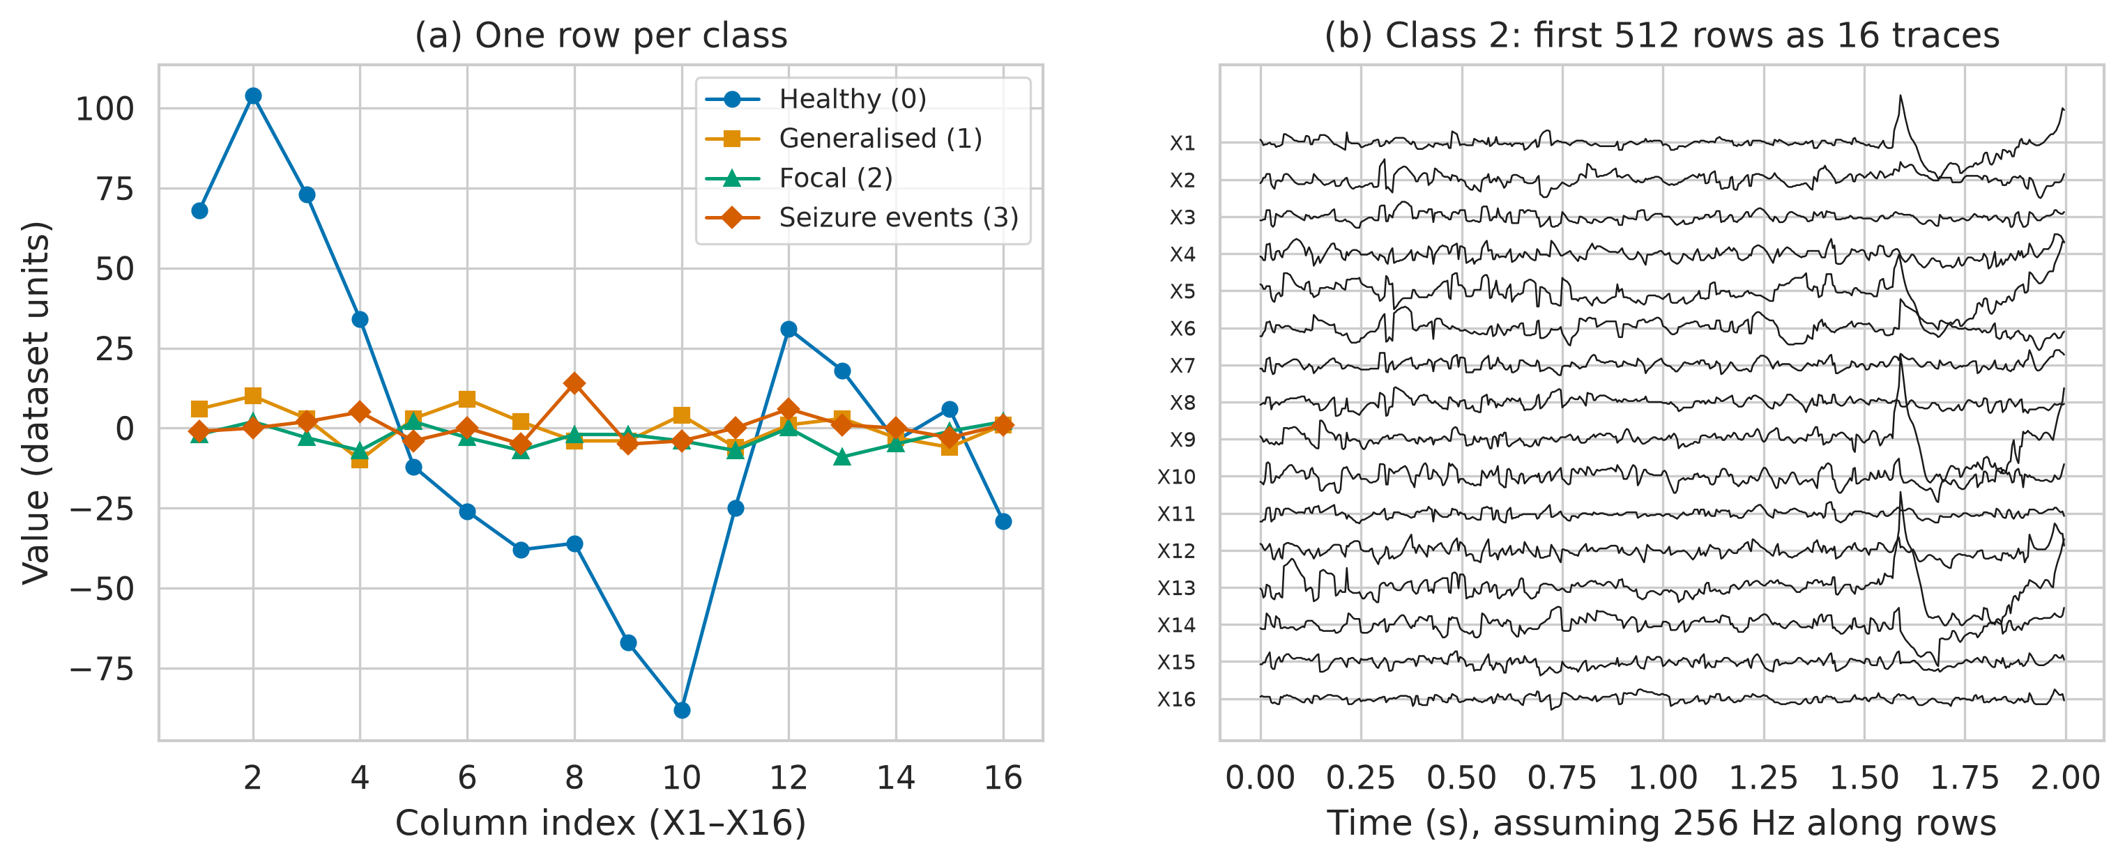
Figure S1. Example rows per class and class-2 rows displayed as 16 traces. (a) One row of each class plotted against column index. (b) The first 512 rows of class 2 plotted as 16 channels over time (2 s at 256 Hz), showing smooth evolution across rows, in contrast with class 0.
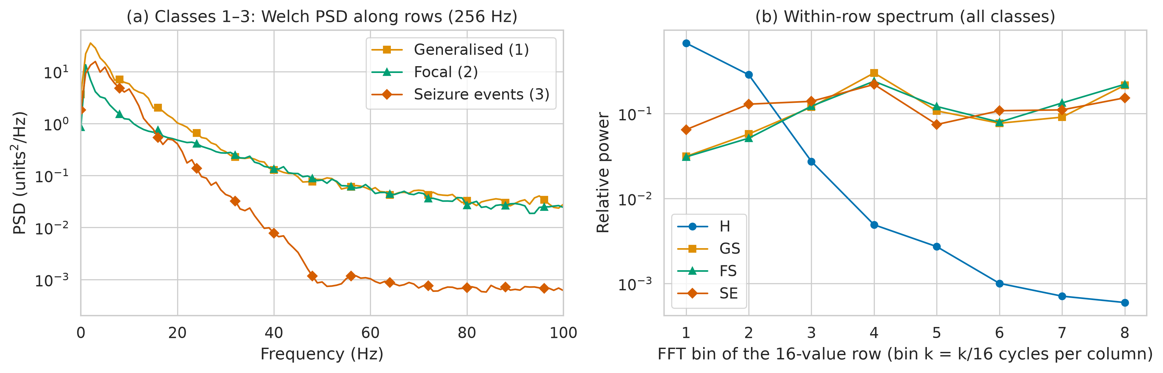
Figure S2. Spectral content of the BEED classes. (a) Welch power spectral density along rows for classes 1–3 (assuming 256 Hz), averaged over channels. (b) Relative power in the eight non-DC bins of the 16-value within-row FFT for all classes.
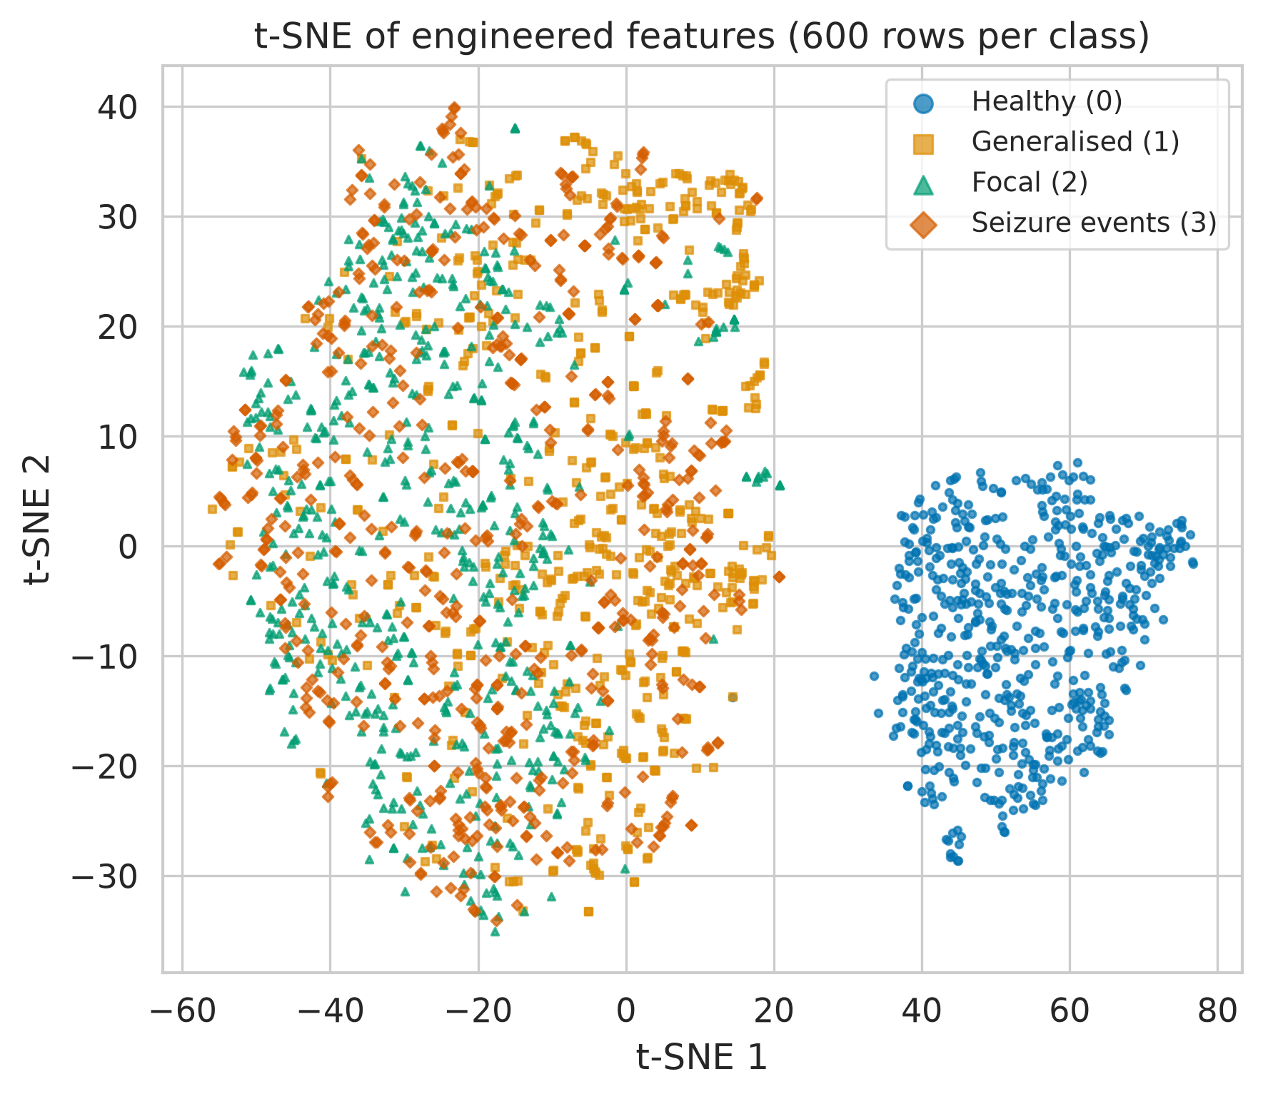
Figure S3. t-SNE embedding of engineered features. 600 randomly selected rows per class; class 0 forms a separate cluster, consistent with its different source.
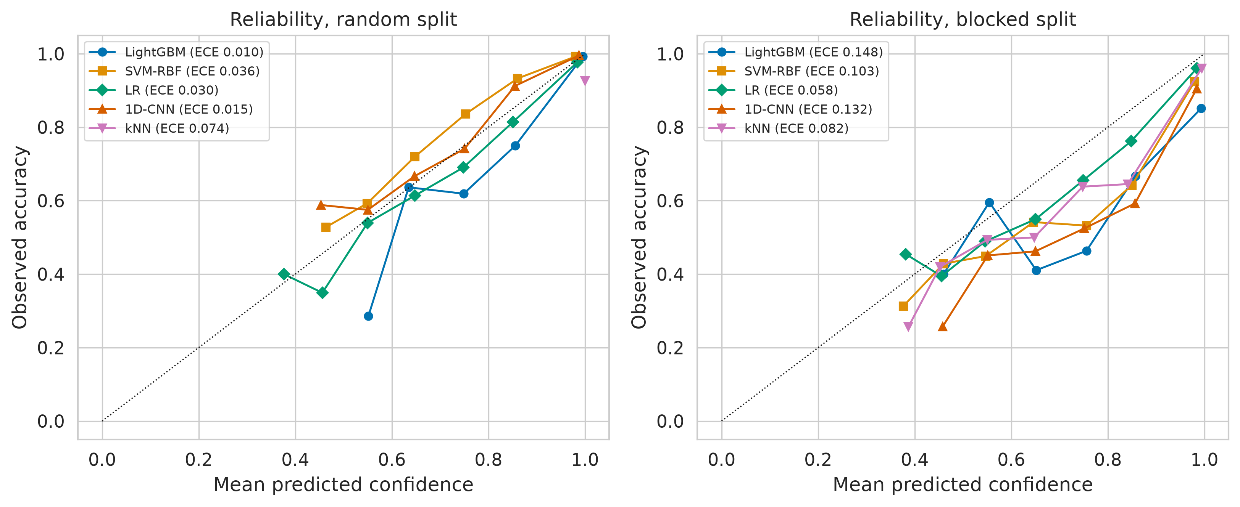
Figure S4. Reliability diagrams on the four-class hold-out test sets. Observed accuracy versus mean confidence in ten bins (bins with fewer than ten samples omitted); legend gives ECE.
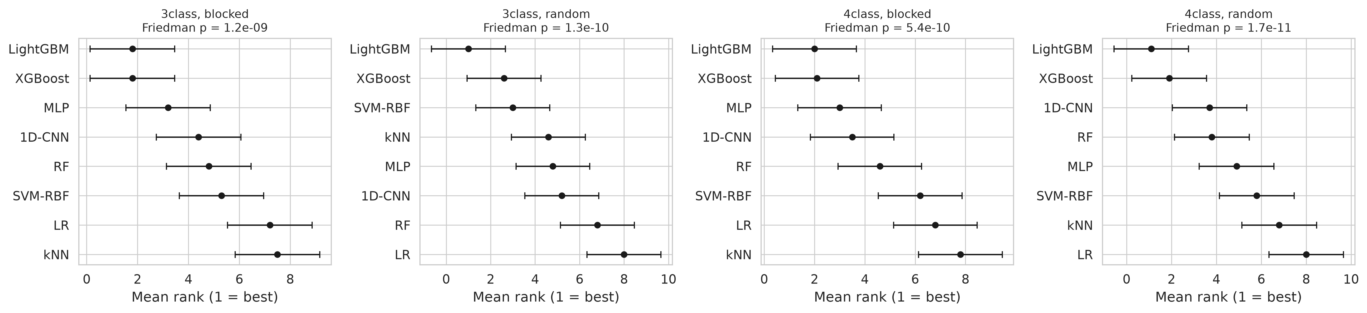
Figure S5. Mean ranks of models across repeated cross-validation folds. Error bars span the Nemenyi critical difference; models whose bars overlap are not significantly different.
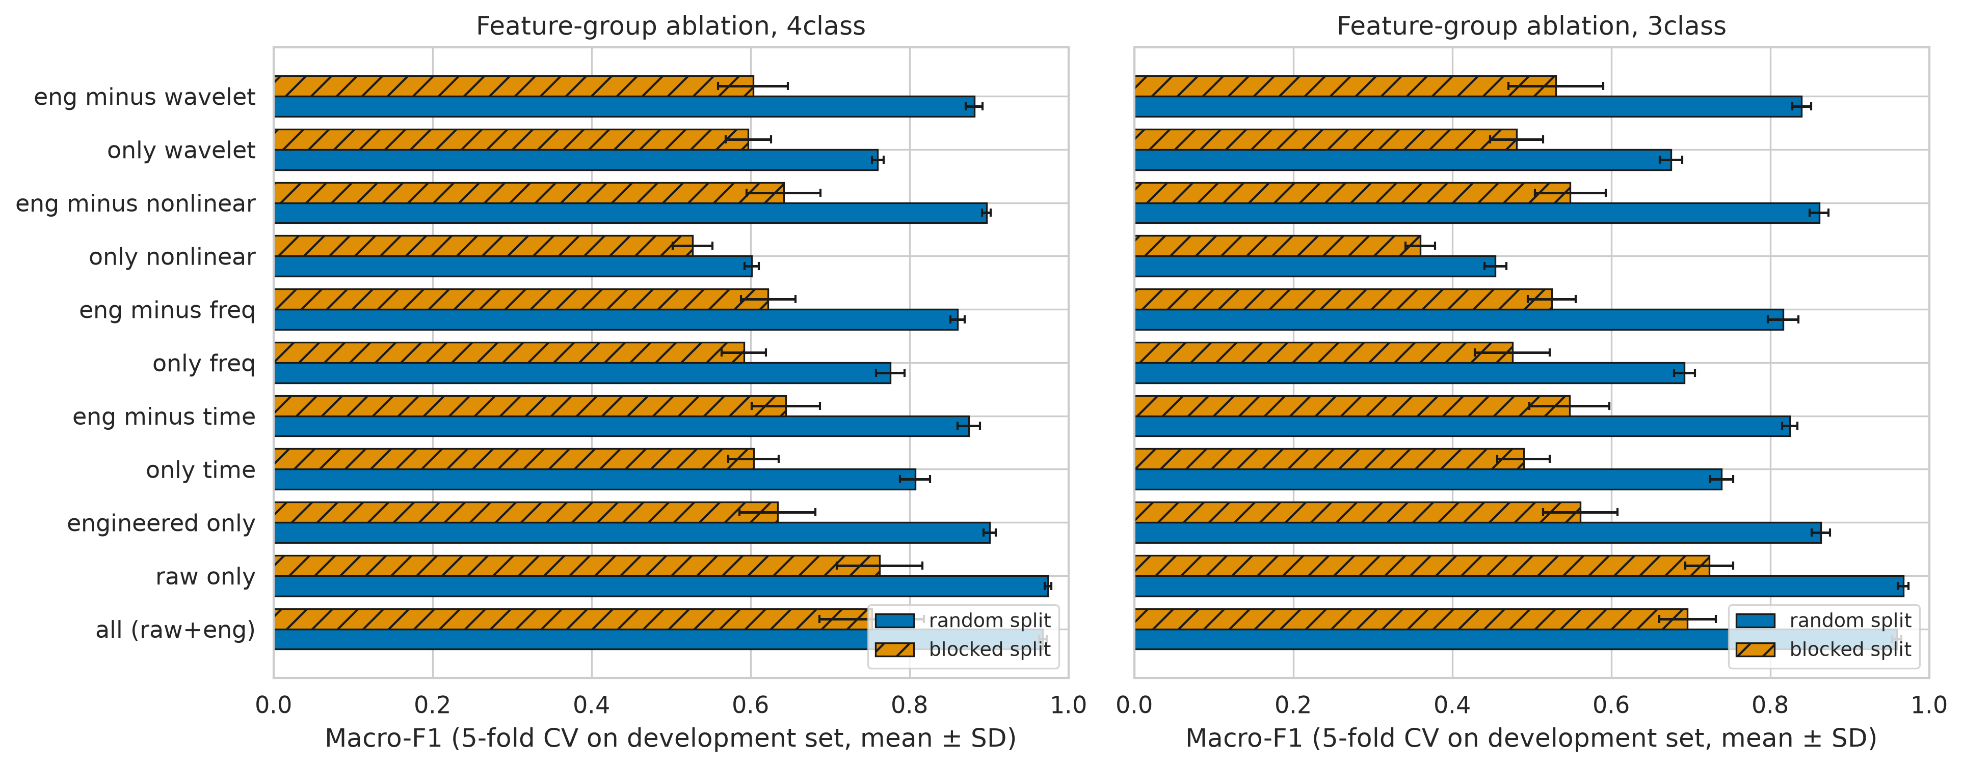
Figure S6. Feature-group ablation under random and blocked protocols. LightGBM with fixed hyper-parameters; five-fold CV on the development set (mean ± SD).
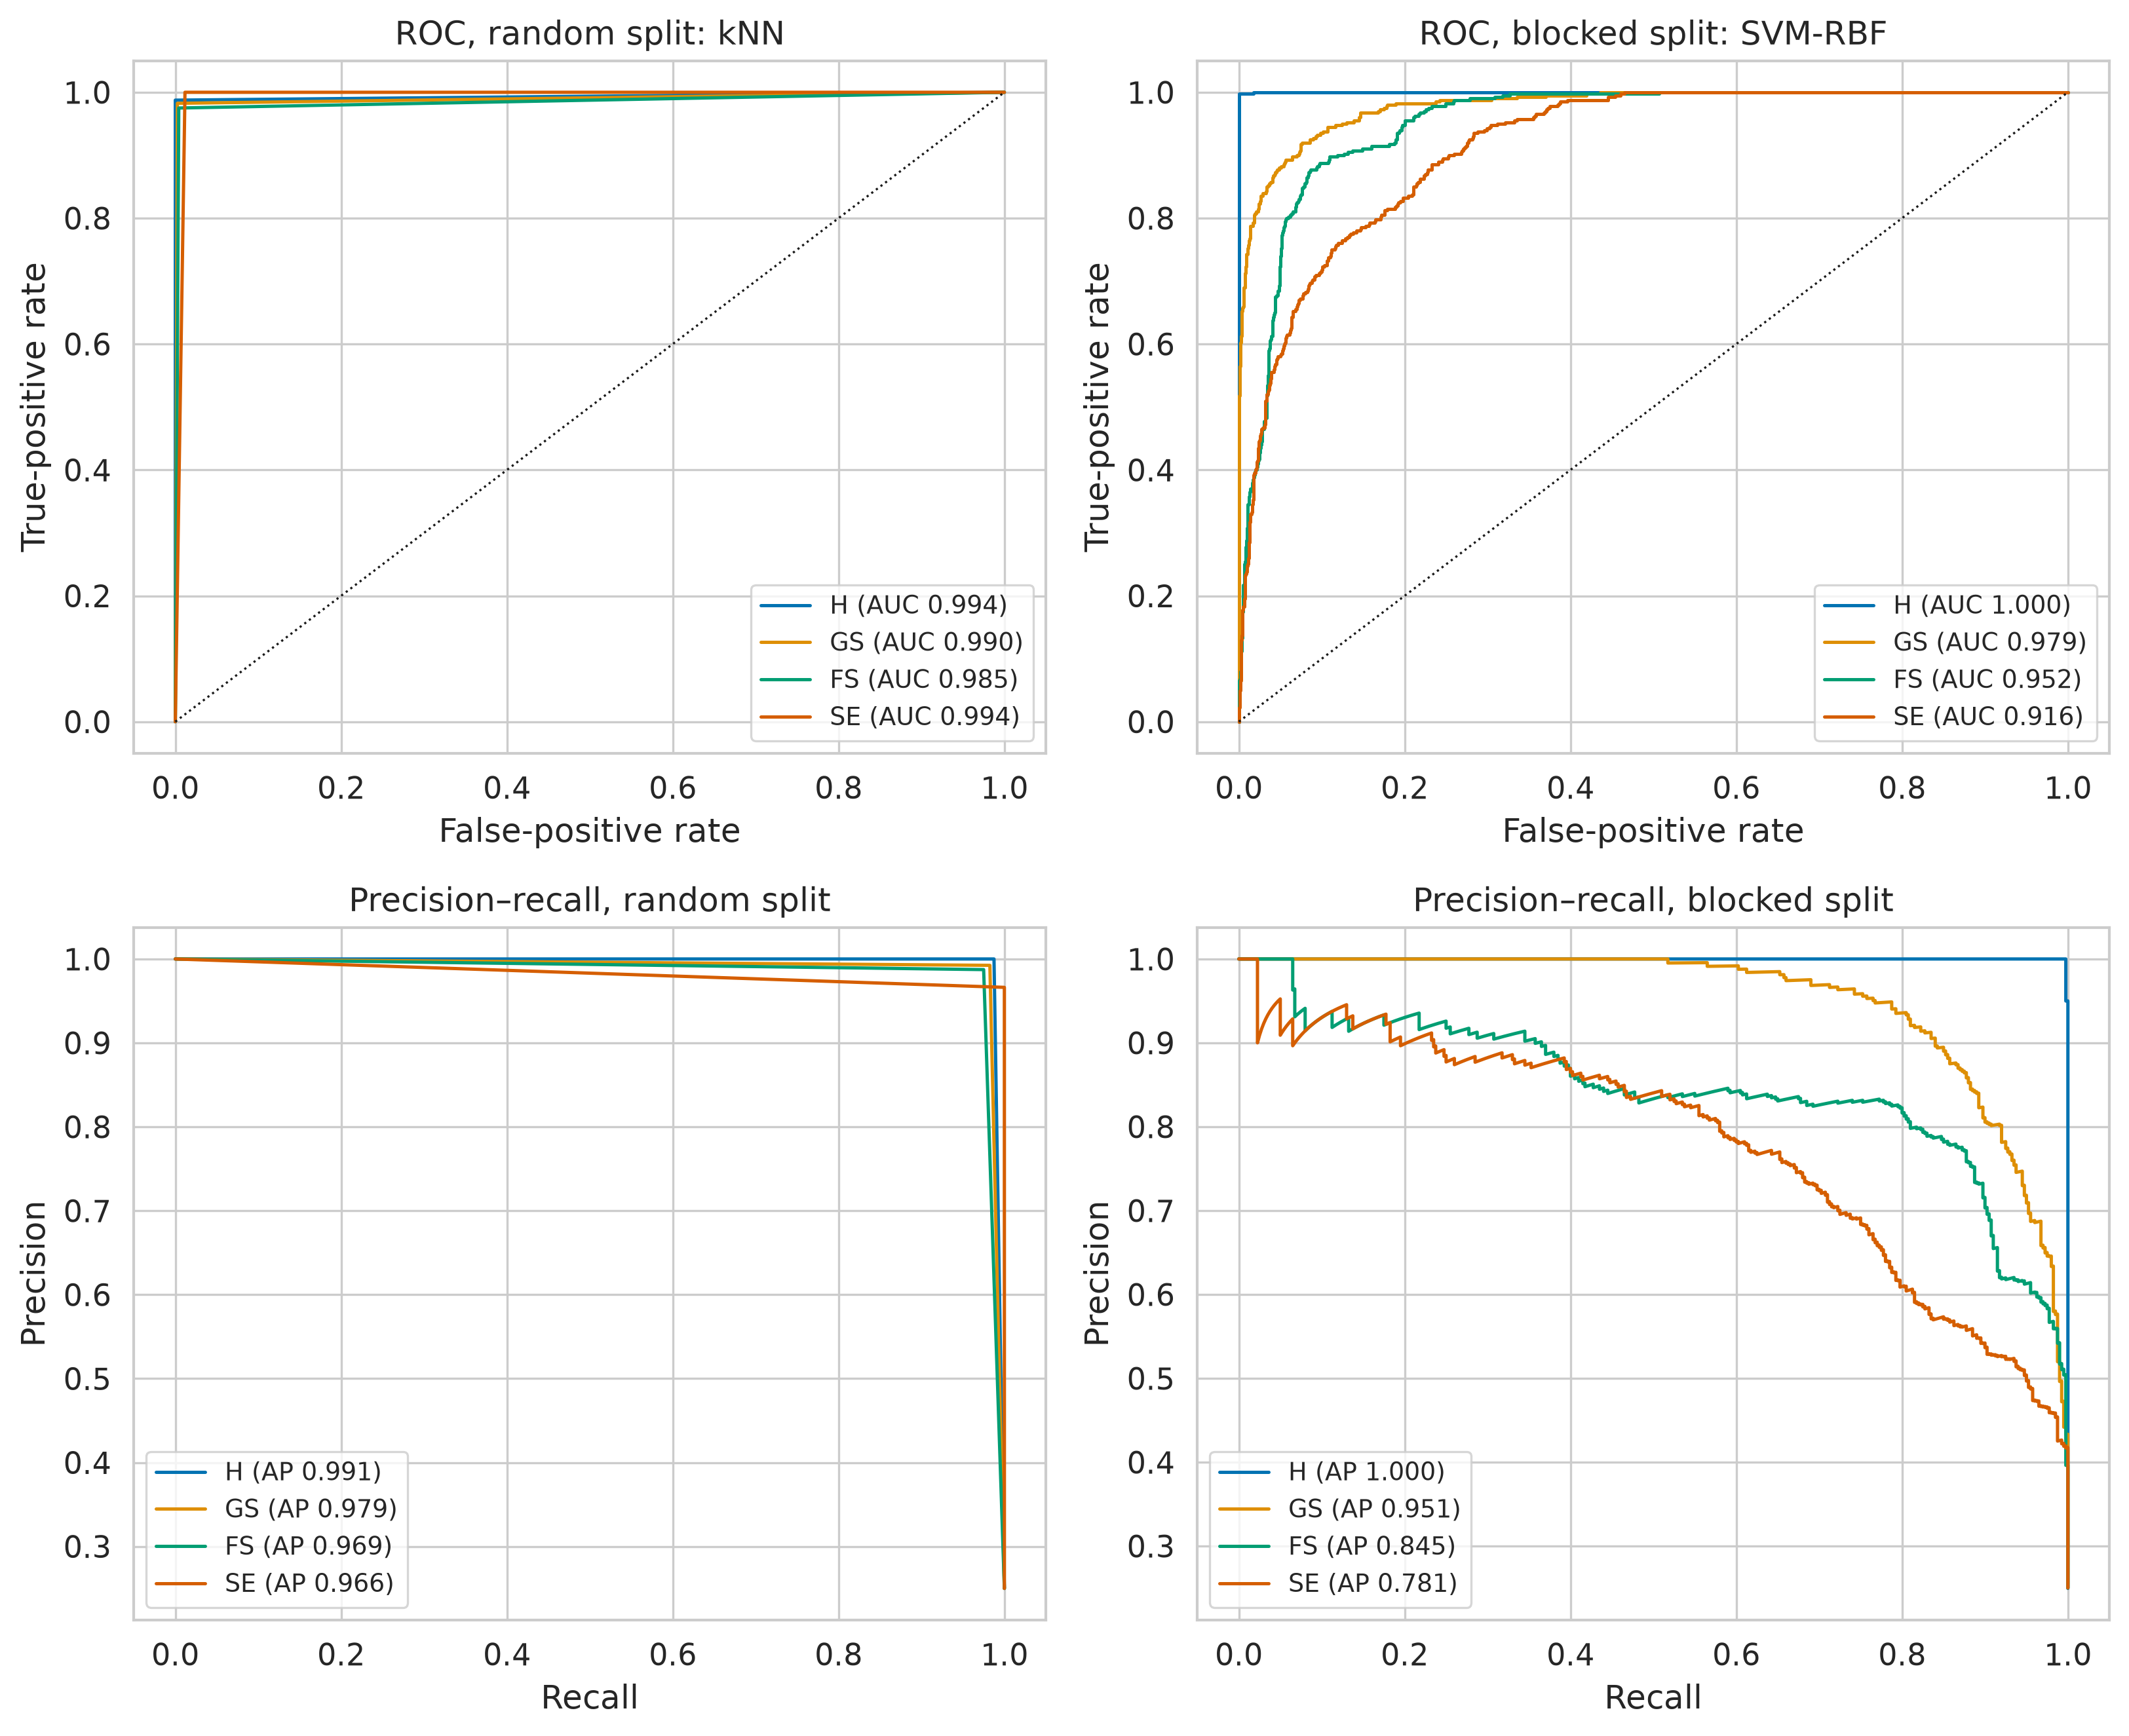
Figure S7. One-vs-rest ROC and precision–recall curves of the best four-class models. Left: random protocol; right: blocked protocol. AUC, area under the curve; AP, average precision.
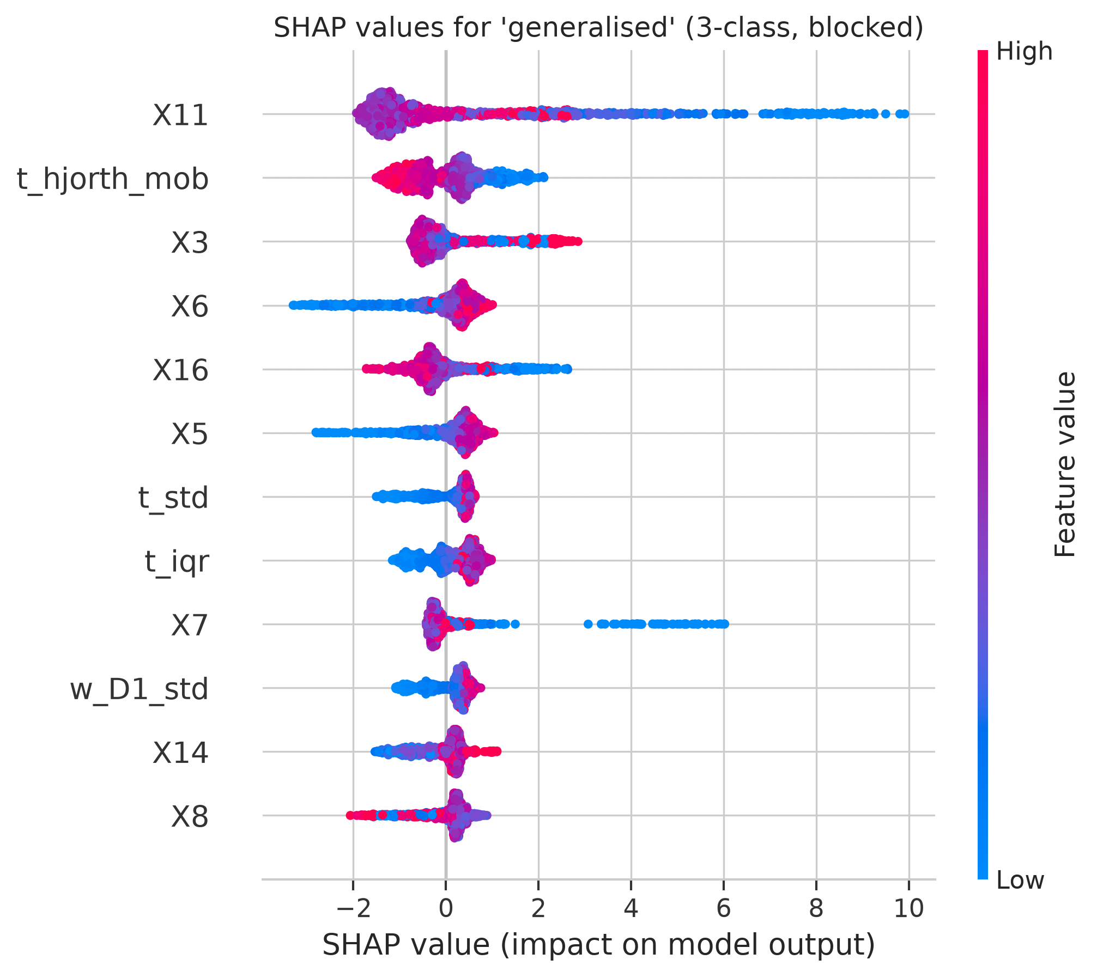
Figure S8. SHAP beeswarm for the generalised-seizure output (three-class, blocked). Each point is one test row; colour encodes feature value (red high, blue low).
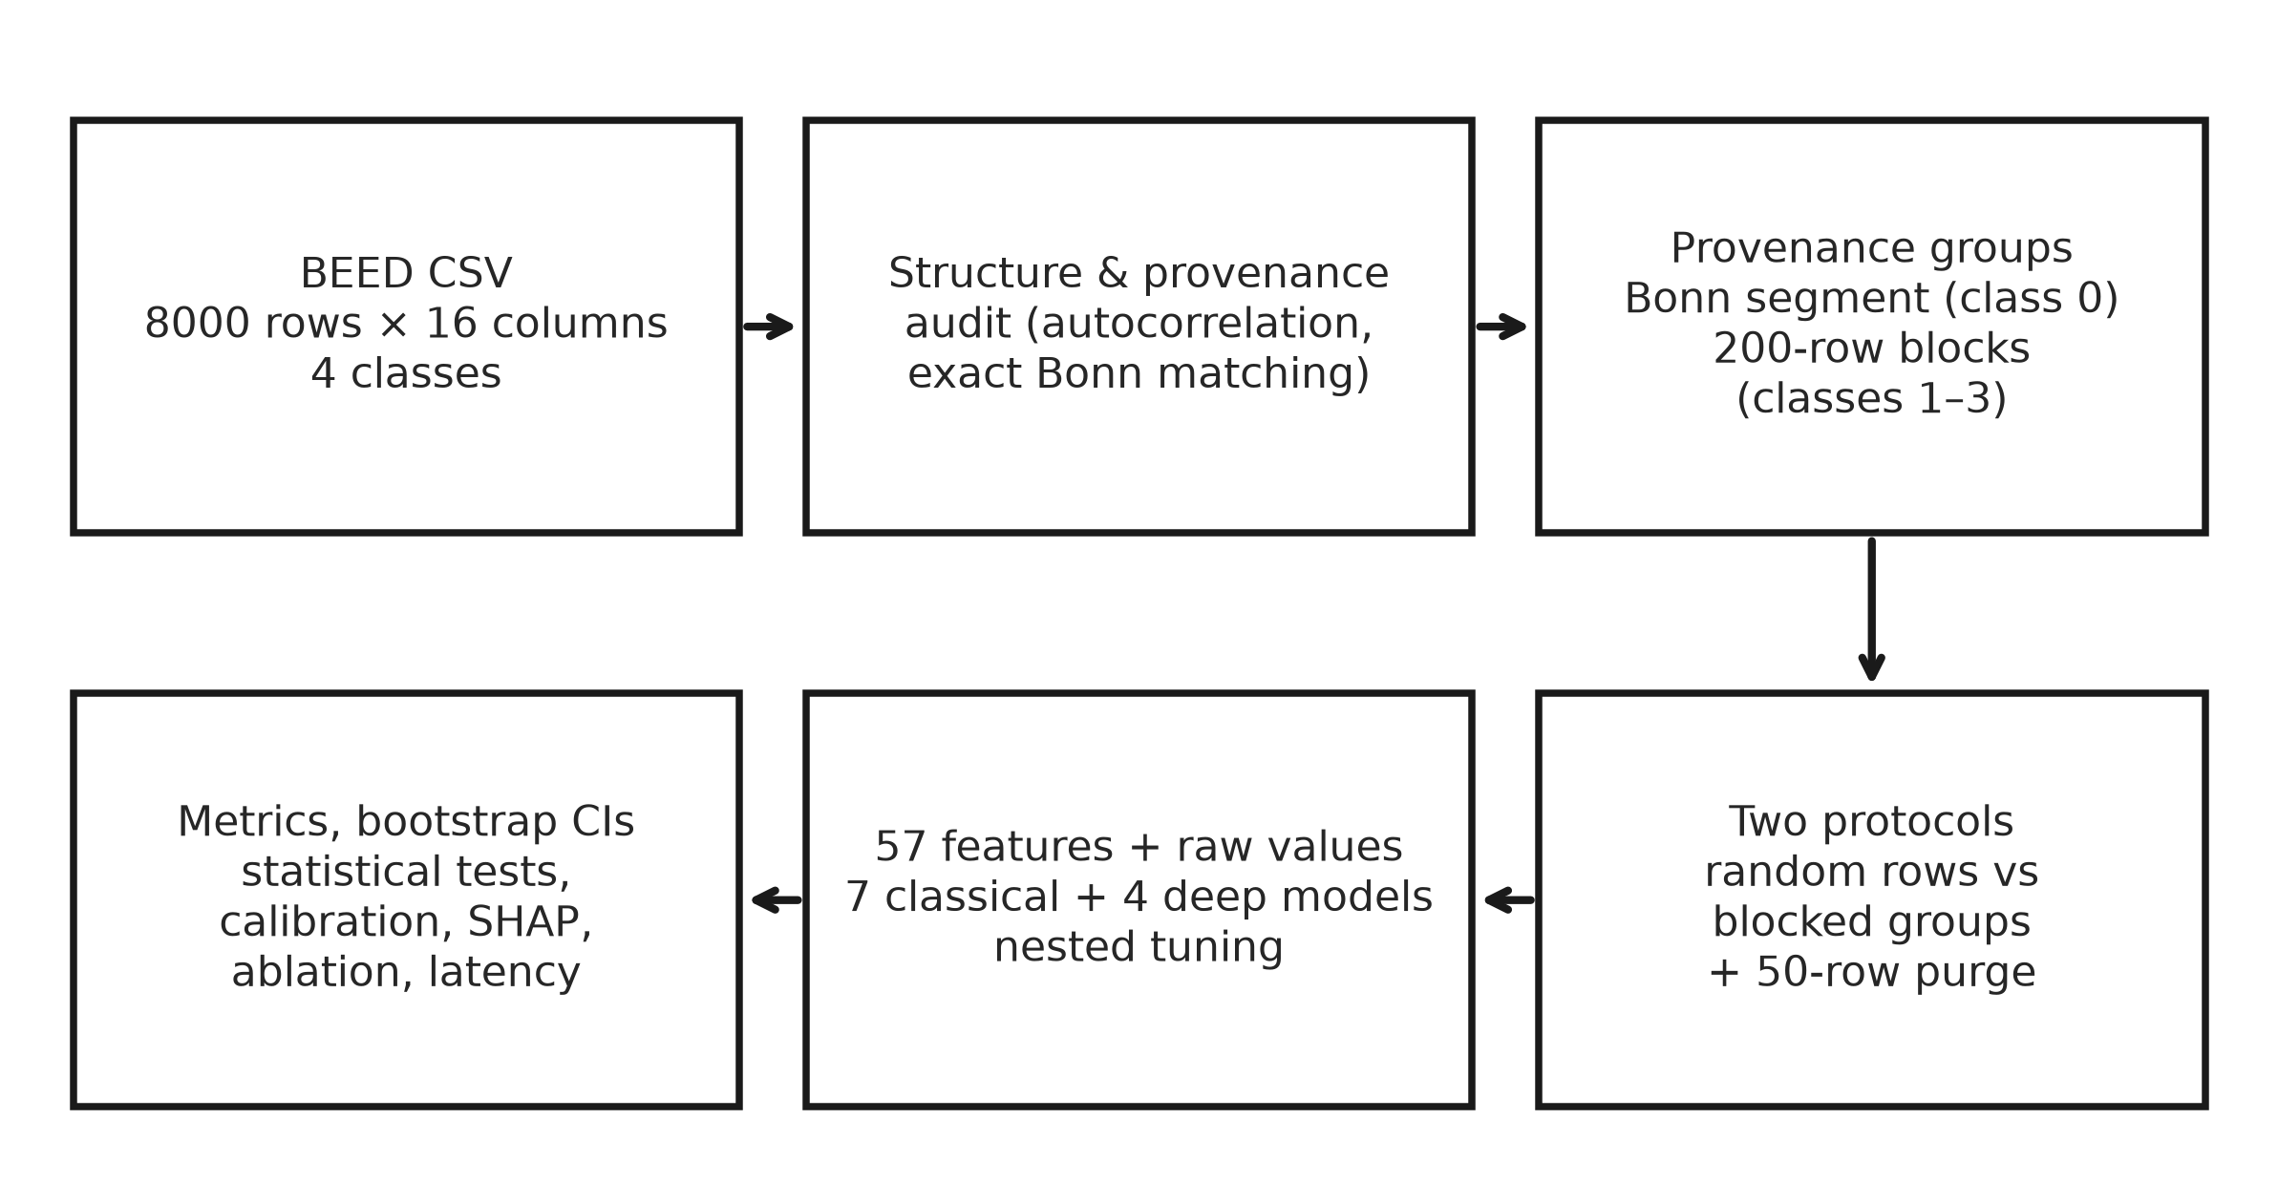
Figure S9. Overview of the audit and leakage-aware evaluation pipeline. Rows are grouped by provenance (Bonn segment for class 0; contiguous 200-row blocks for classes 1–3) before any split. Both protocols use the same features, models, nested tuning and metrics.
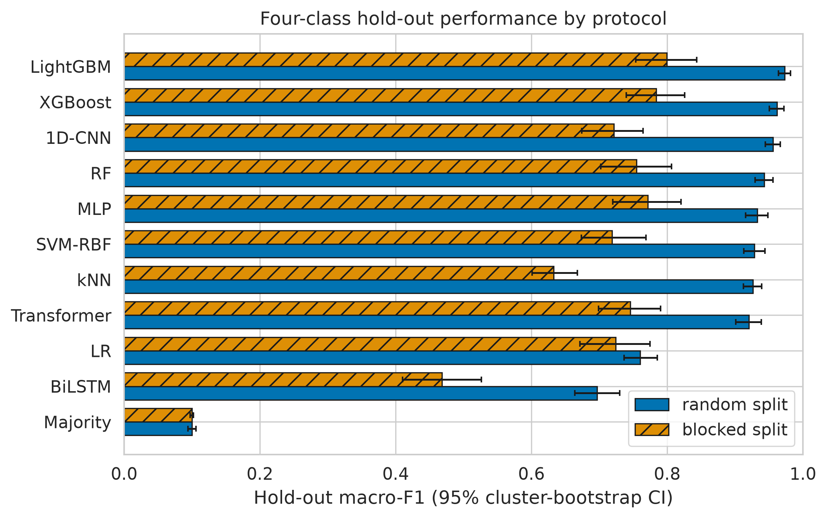
Figure S10. Four-class hold-out macro-F1 under random and blocked protocols. Classical models on raw+engineered features; deep models on raw values. Error bars: 95% cluster-bootstrap CIs. Hatched bars: blocked protocol. The same values are tabulated in Table 3 of the paper and Supplementary Table S2.

